1. For FLEXTYPE_OLY_RevC.zip:
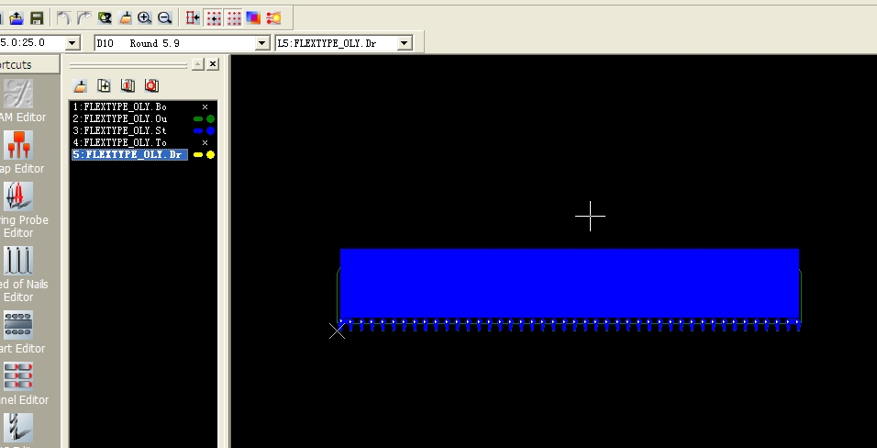
The black area is LPI. The blue area is without LPI.
It is the top solder mask in the above picture, its design is same with Flextype_U5_RevD, and we don’t know which area are need to add LPI.
It is also same problem in FLEXTYPE_R10_RevC.zip & FLEXTYPE_SC_RevC.zip.

2. For FLEXTYPE_UWP_RevC:
kindly see its bottm circuit:
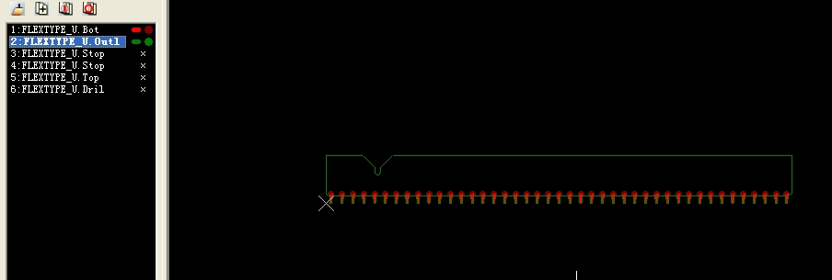
and its bottom solder mask:
The black area is coverlay. The blue area is without coverlay. You are correct -- The blue area you are pointing to has no copper. (I will be gluing this area to an assembly, but coverlay is hard to glue to).
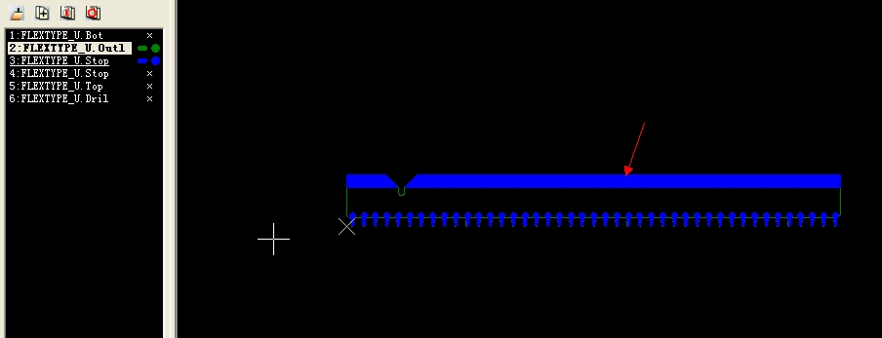
Pls see the area that red arrow points at, there is not any copper in the bottom circuit, then mean it just have base material, but it shows that it doesn’t have solder mask in the pads of the solder mask layer, so we don’t know what this area is.

Pls see the top circuit for FLEXTYPE_UWP_RevC:
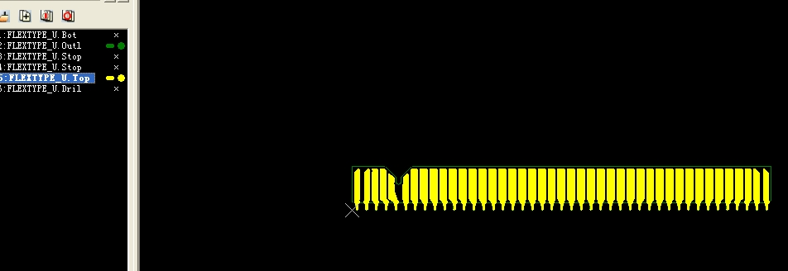
and its top solder mask for FLEXTYPE_UWP_RevC:
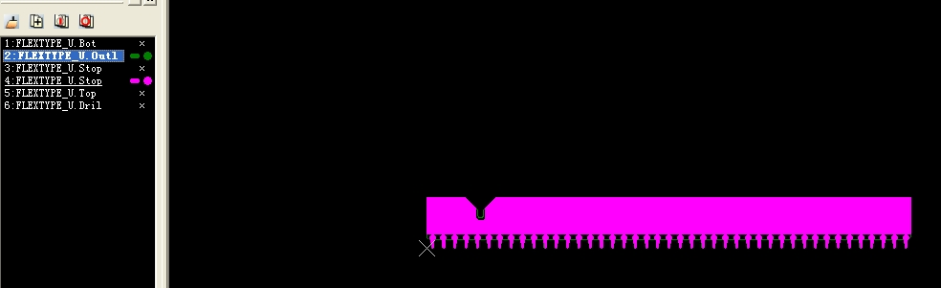
The black area is LPI. The purple area has no LPI. The “U” shape LPI is a mistake – I am sending a new Gerber now ( Flextype_UWP_RevD.zip )
This design of top layer is same with Flextype_U5_RevD, we don’t know which area are needed to add LPI.

Besides, another thing has to say sorry to you, because I recommend yellow color LPI to you this morning, my manager had criticized to me about this just now. At present, the LPI colors that are suitable for flexible material, most are black color & white color, and a spot of green color, but yellow color, still don’t use on this aspect at present.
Please use White LPI.

If I don’t understand wrong, do you mean to add the LPI in the area between pin and pin? If yes, it will be difficult to do so.
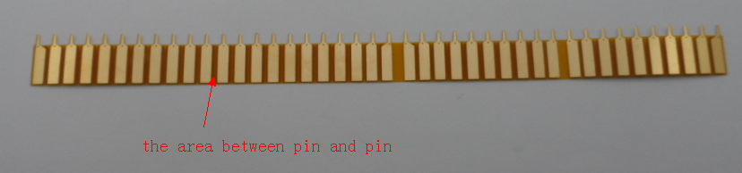
I do not need to cover the area between pin and pin. I want to cover parts of each pin. This stops solder flowing too far. I am not interested in covering between pin and pin if it is hard to do.
We must find the best way for the production to save the cost for you.

